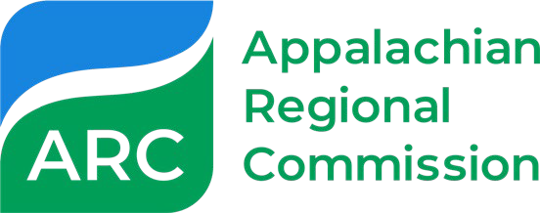

Appalachian Regional Initiative for Stronger Economies (ARISE)

Concept Paper Template

Applicants interested in applying for ARISE funding—for either an implementation or planning award—must first submit a concept paper in PDF format to ARISE@arc.gov. Once receipt of the concept paper is confirmed and any preliminary questions are addressed, the concept paper will be forwarded to the ARC state program managers of each state impacted. NOTE: Submission of the concept paper does not replace or satisfy the requirement that applicants must contact the appropriate state program managers prior to concept paper submission. Only one concept paper is needed for each multistate proposal.

Applicants may receive an invitation and instructions to submit a full application upon review and completion of the concept paper screening process.

Please note: Complete concept papers should be a maximum of four pages in length. You may use this template as a guide, but it is not a requirement of submission.

Refer to the Request for Proposals sections on concept papers (pages 6 and 14) for more information on application requirements and how they will be reviewed.

Applicant Name
Applicant Mailing Address
Applicant Point of Contact
(include job title)
Email
Phone

Tentative Project Title
Implementation grant or planning grant?
ARC Funding Requested | The amount requested and a brief explanation about how the funds are expected to be used.
Project Length | e.g. 24-months
List of Key Partners | Please list partners and their expected roles in this project. Please also include each partner’s State affiliation.
Geographic Scope | Please list impacted State(s), as well as the target Counties in each state. A consolidated list of Appalachian Counties Served by ARC is available.

NEXT PAGE

Detail re: Correspondence with State Program Managers. | This is the applicant’s opportunity to describe the nature of their correspondence with State partners and demonstrate State interest in the proposed project concept.  This could be formatted as: [Applicant] held a joint video call with the State Program Managers, in X, Y, and Z State, on X day. We discussed A, B, C topic and received X feedback.

Please provide a brief Summary of Proposal. Do not include any attachments.

This could include a project goal, project description, project results/outcomes.

For additional information on ARISE, please see: https://www.arc.gov/arise/ or contact ARISE@arc.gov.

