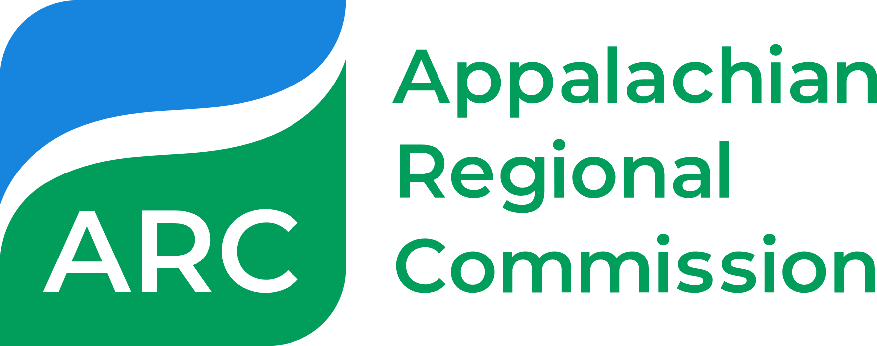

Appalachian Regional Initiative for Stronger Economies (ARISE)
Planning Grant – Concept Paper

COVER PAGE – REMOVE THIS PAGE PRIOR TO SUBMISSION
Applicants interested in applying for ARISE planning funds must submit a concept paper of no more than six pages adhering to this template to ARISE@arc.gov. Note: Prior to submitting this concept paper, applicants must first submit a Project Summary via email to the state program managers in all states impacted by the proposed project and must receive confirmation of receipt, at minimum, from all state partners. Applicants who do not meet this step will not be moved forward in the review process.

After you submit your concept paper to ARISE@arc.gov, ARC will confirm receipt and inform you of any preliminary questions to be addressed, as applicable. If the concept paper sufficiently addresses all components of the concept paper template laid forth below, ARC partners will review the concept paper. Upon review, applicants may receive an invitation and instructions to submit a full application. Applicants not selected to submit a full application will be informed of the decision.

Concept papers will be reviewed every two months, starting the day after the first submittal deadline.
Round | Submittal Deadline
1 | October 31, 2023
2 | December 31, 2023
3 | February 29, 2024
4 | April 30, 2024
5 | June 30, 2024
Concept papers that do not adhere to the template, are incomplete, or are insufficient by the dates indicated may be considered during the next bi-monthly review period, subject to the availability of funds.
Please note: Complete concept papers must be a maximum of six pages in length with no attachments. You may remove the help text in the template (text in italics) prior to submission. Minor changes in formatting (font type, font size, etc.) are permissible as long as all sections of the template are covered. Incomplete concept papers or concept papers that deviate from the template significantly may not be moved forward in the review process.
Only one concept paper is needed for each multistate proposal.
Refer to the Notice of Solicitation of Applications (NOSA) sections on concept papers for more information on application requirements and how they will be reviewed.

Appalachian Regional Initiative for Stronger Economies (ARISE)
Planning Grant – Concept Paper
NOTE: Complete concept papers must be a maximum of six pages with no attachments.

Contact Information
Applicant Name
Applicant Mailing Address
Applicant Primary Contact Name and Job Title | Please also include the Primary Contact’s position/job title.
Email
Phone
Is the applicant a fiscal agent or principal partner on an open ARISE, INSPIRE, POWER, WORC, or Area Development grant? | Yes / No. If yes, provide Project ID number(s) to open projects.  Note: Applicants are permitted to have more than one open ARC project at a time so long as project scopes differ between projects.

Project Summary
Project Title
Project Length | Planning projects may last up to 12 months.
ARC Funding Request – Summary | Please identify the total amount requested.  The maximum funding available for planning grants is $500,000.
ARC Funding Request – Breakdown | Provide amounts (estimates are acceptable) for each of the following spending categories. These spending categories mirror the spending categories in the Federal Standard Form 424 (SF-424), which you should expect to complete should you be invited to submit a full application.  Spending Category ARC Amount Narrative (~1 sentence)  Personnel  Fringe  Travel  Equipment  Supplies  Contractual  Other  Total Direct Charge  Total Indirect Charge  Total ARC Request
Match Breakdown | ARC does not expect all match sources to be identified or secured at the time of concept paper submission; however, at the time of submission, applicants should have calculated their anticipated match rate based on their projects’ geographic scope and started to think about potential sources of match funding. Guidance on match requirements for ARC grants is available here.  Expected Match Rate X%  Match Match Amount Source of Funds  Other federal funds E.g., other federal  State E.g., state grants  Local E.g., applicant, partners, etc.  Total Match
Geographic Scope — States | List states impacted by this project. Note, projects must serve and benefit, at minimum, two (2) states within a portion of the Appalachian Region.
Geographic Scope — Counties | List target counties in each state listed above. A consolidated list of Appalachian counties served by ARC is available.
Project Summary submitted to and, at minimum, acknowledged by all states’ program managers? | Yes / No

Partnerships
List of Key Partners and Their Roles | List all confirmed project partners AND their expected roles in this project. Listing partners alone will not suffice. Expect to provide one to two sentences of detail for each project partner. Please also include the primary contact information (name, email, and phone number) for each listed partner.  Be sure to include each partner’s state affiliation. Note: There must be at least two (2) eligible organizations collaborating across more than one Appalachian Region state to be eligible. There must also be at least one partner from each state within the project area.  ARC understands that part of the objectives/goals of a planning grant could be to form new partnerships in the target region. If forming new partnerships is part of your proposed project, please also briefly identify the types of new partners you aim to develop (e.g., school districts, private sector partners, etc.) through the life of this project.

Project Narrative
Project Rationale / Statement of Need | Provide a concise explanation (one to two paragraphs) for the rationale/need for this project. Be as specific to the project’s target geographies as possible and feel free to cite data. ARC has a vast Research and Data Library we welcome you to use and refer to.  Articulate what gaps this project aims to fill (and how this project avoids overlapping/duplicating ongoing efforts in the region) and what specific opportunities lie within the target geographies that this project aims to leverage. Explain why this project requires or benefits from a multistate approach and why a planning grant is needed.  Through this narrative, ARC should be able to understand why the states impacted by the proposed project, and the Appalachian Region overall, need and/or would benefit from this project.
Project Goal | Briefly summarize (a few sentences) what you and project partners aim to accomplish by the end of the proposed project. Remember that the primary aim of ARISE is to advance multistate economies. Your project’s goal(s) should tie into the potential economic impact your project will have on your target region.  Planning grants also often aim to prepare project partners for a potential follow-up/implementation project. Make sure you articulate how this planning grant is setting partners up for future success.
Project Description | The bulk of your concept paper should be used to describe your project, i.e., what you will do to accomplish the goal(s) articulated above. In this section, please clearly and succinctly explain your project design/project activities and be as precise as possible.  By the end of this section, ARC should clearly understand what you will do during the proposed project and how those activities tie back to the project goal(s). ARC acknowledges that applicants are limited to six pages in the concept paper. With space limitations in mind, prioritize by including the most relevant information. If you are invited to apply, you will be able to provide more details at that time.  ARC encourages applicants to use the Workplan and Timeline tables (below) to complement any narrative and to help articulate your project design/activities. Applicants are not required to follow this table format if the same information is covered in an alternative format.  Timeline: [State when in the project you will complete the objective(s) listed]  Goal Objective(s) Partners Responsible  [Concisely state the goal of this portion/timeframe in your project] [List the specific tasks to achieve this goal] [State which partners are responsible for/contributing to the objective(s) listed]  Timeline: [State when in the project you will complete the objective(s) listed]  Goal Objective(s) Partners Responsible  [Concisely state the goal of this portion/timeframe in your project] [List the specific tasks to achieve this goal] [State which partners are responsible for/contributing to the objective(s) listed]
Project Description  Example | EXAMPLE – REMOVE BEFORE SUBMISSION  (This is an example only; every project is unique. This example is not intended to suggest ARC endorsement of a specific project or project type.)  Timeline: Q1  Goal Objective(s) Partners Responsible  Organize and coordinate project partners. Begin process of onboarding consultant. - Develop and release contractor RFPs, following the organization’s written procurement guidelines and federal/state regulations. - Review proposals and hire consultants. - Hold project kickoff meeting to discuss roles, finesse timeline, set expectations. - Dream Appalachia (lead) will create the first draft of the RFP and all partners will have the opportunity to provide feedback. - Partners will provide review and score RFP responses. Dream Appalachia will make final approval. - Dream Appalachia (lead) will be responsible for organizing kick-off.  Timeline: Q2  Goal Objective(s) Partners Responsible  Establish relationship with consultant and monitor progress. - Regularly meet with consultant and partner working group to review plan development progress. - Consultant gains public feedback on data collection and potential solutions. - All partners - Consultant leads feedback sessions in conjunction with Dream Appalachia.  Timeline: Q3  Goal Objective(s) Partners Responsible  Make progress on work plan development. - Continue consultant and partner working group meetings. - Contractor delivers draft plan. - Partner working group reviews the plan and provides edits and feedback. - All partners - Consultant - All partners review and provide feedback.  Timeline: Q4 (and so on)  Goal Objective(s) Partners Responsible  Finalize work plan and share with stakeholders. - Final draft - Share draft with stakeholders for ground-truthing. - Accept final report. - Consultant - Dream Appalachia and partners - Dream Appalachia
Results at End of Project | ARC would like to understand what, concretely, the applicant expects will result from this planning grant. Commonly, planning projects result in newly developed plans or reports that set the applicant up for success in a future implementation project. This could include strategic plans, master plans, concept plans, or plans for infrastructure improvements or new programs, as well as research reports, feasibility studies, pilot programs etc.
For additional information on ARISE, see https://www.arc.gov/arise/ or contact ARISE@arc.gov.

